**Level 1: Intro Isles**

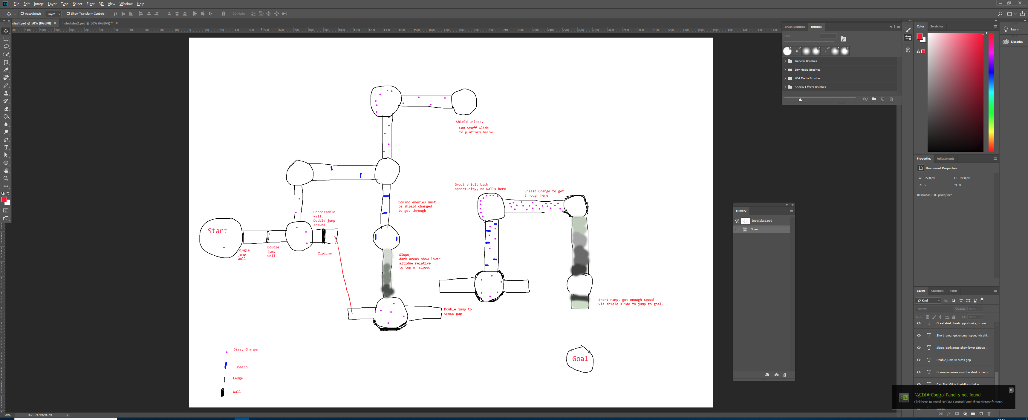

Figure - The initial layout of Intro Isles.

**First Drafts:**

This was the first draft for the layout of Intro Isles. This tutorial stage introduced both the sword and the shield to the players, skill gating double jumps, shield charges and the shield slide, along with the dizzy chargers and the domino enemies. Two shortcuts involving later techniques exist, the red zipline and using the staff hover to get to a far away platform, in addition to a skip once you have already obtained the shield.

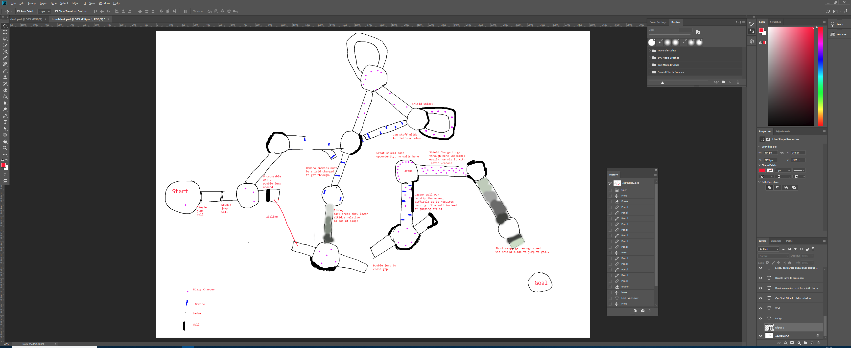

Figure - The redesign after reconsideration.

**Second Draft:**

The second draft moved most of the islands around, to make the 90 degree turns less sharp, and so more manageable at speed. Small developments were the loops that make the tighter turns feasible, the return path after picking up the shield and the small ramp to make the shield skip more obvious. A new shortcut was made, by using the daggers to wall run on the outside of a wall and skip an arena, probably followed up with a grapple shot to land back on the platform. Some of these skips require other skips to be missed, like the staff glide preventing the zipline and dagger run being utilised.

**Visuals Design and Aesthetics:**

Visual design wise, the stage would be made up of rulers, tin cans and cardboard, creating an arts and craft feel. The use of a blue carpet and sandpaper would set up a beach theme to it. As the first stage, it would receive the intro of the toys getting put in the upturned laundry basket.

**Construction:**

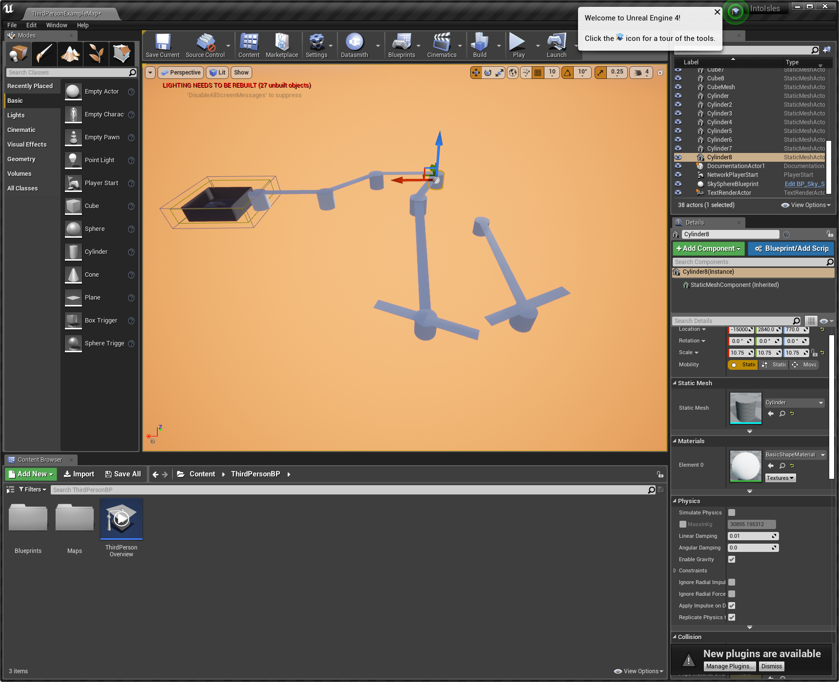

Figure - The beginning of the white boxing. The sunset is used solely so that the level is more visible, but for a seaside level, it fits.

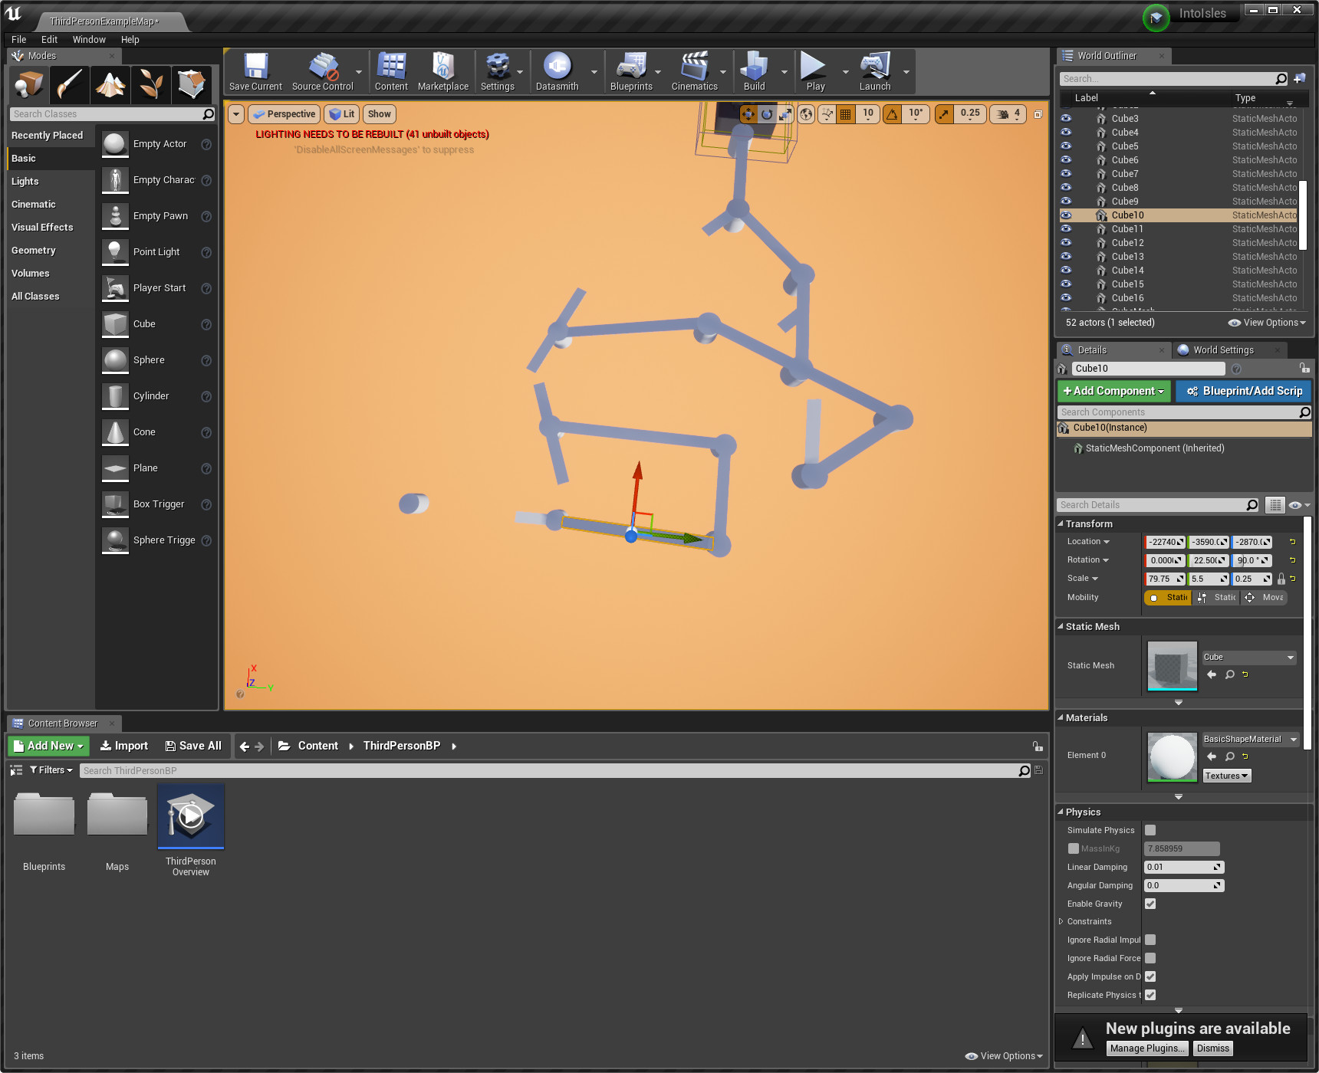

Figure - All the main routes made.

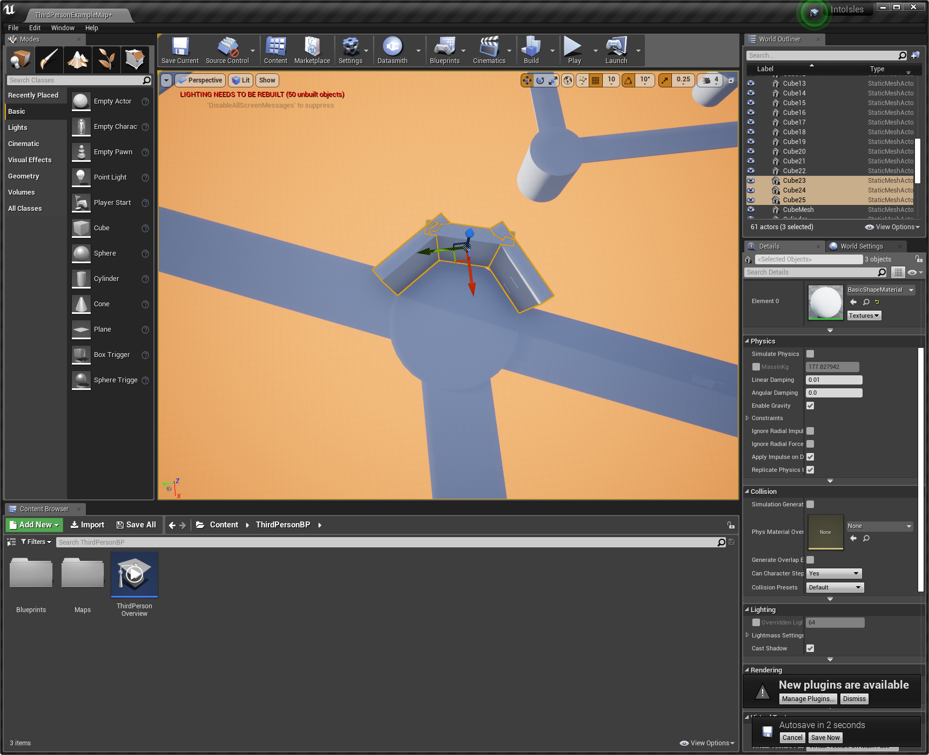

Figure - Implementing the walls.

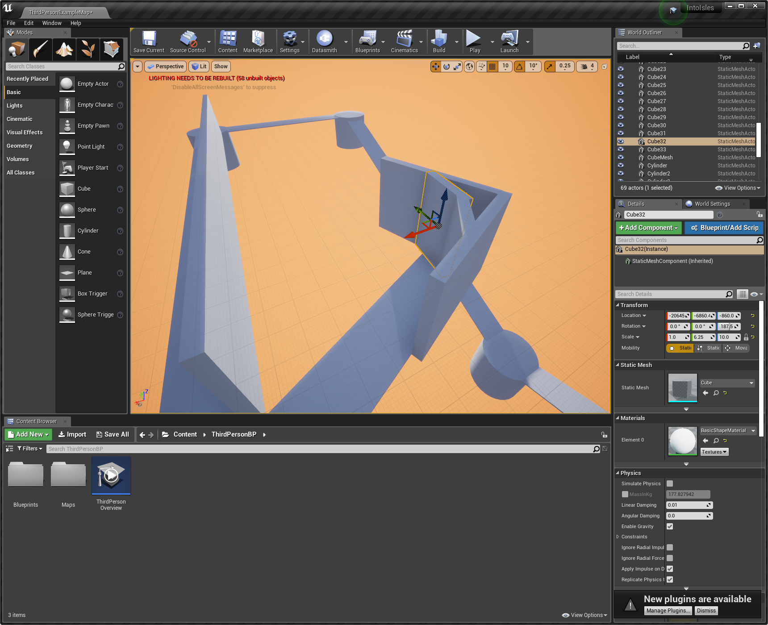

Figure - The walls for the wall run shortcut.

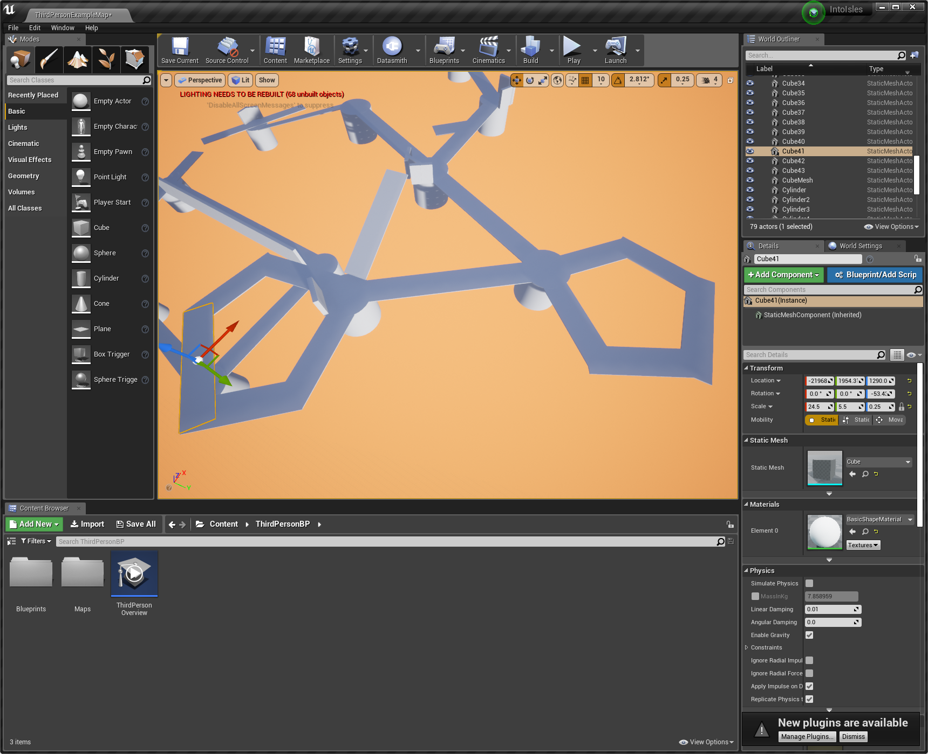

Figure - The loops to make the tight turns.

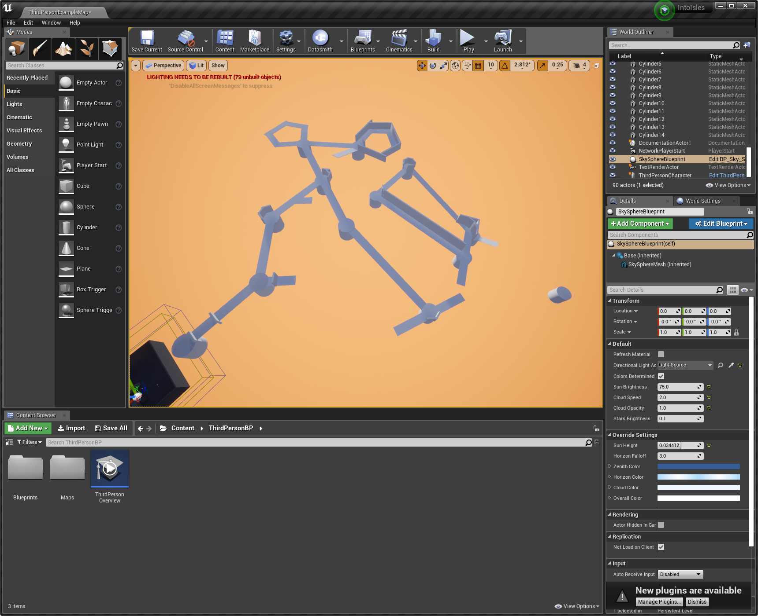

Figure - The completed level layout

**The completed level layout:**

From here we can playtest the level, and determine is any corners are too sharp, or any jumps too hard to make. Once we are happy with the layout, we can focus on the lighting, textures, background details and enemy placements.